UNITED STATES
SECURITIES AND EXCHANGE COMMISSION
Washington, D.C. 20549

FORM 6-K

REPORT OF FOREIGN PRIVATE ISSUER

Pursuant to Rule 13a-16 or 15d-16 Under the
Securities Exchange Act of 1934

For the month of September 2026

Commission File Number: 001-42931

Grupo Aeroméxico, S.A.B. de C.V.
(Name of registrant)

Aeromexico Group
(Translation of registrant’s name into English)

Avenida Paseo de la Reforma 243, 25th Floor
Col. Cuauhtémoc, Cuauhtémoc 06500
Mexico City
United Mexican States
+52 (55) 9132 4000
(Address of principal executive office)

Indicate by check mark whether the registrant files or will file annual reports under cover Form 20-F or Form 40-F.

Form 20-F ☒ Form 40-F ☐

EXPLANATORY NOTE

On September 18, 2026, Grupo Aeroméxico, S.A.B. de C.V. (the “Company”) issued a press release titled “Unusual Movements in the Trading Price of the Shares Representing the Company’s Capital Stock.”. A copy of this press release is furnished with this Form 6-K as Exhibit 99.1.

EXHIBIT INDEX
Exhibit |  |  |  |  |  | Description
99.1 |  |  | Press Release dated September 18, 2026, titled “Unusual Movements in the Trading Price of the Shares Representing the Company’s Capital Stock.”

SIGNATURE

Pursuant to the requirements of the Securities Exchange Act of 1934, the registrant has duly caused this report to be signed on its behalf by the undersigned, thereunto duly authorized.
 |  |  | Grupo Aeroméxico, S.A.B. de C.V.
Date: September 21, 2026 |  |  | By: |  |  | /s/ Ernesto Gómez Pombo
 |  |  | Name: |  |  | Ernesto Gómez Pombo
 |  |  | Title: |  |  | General Counsel

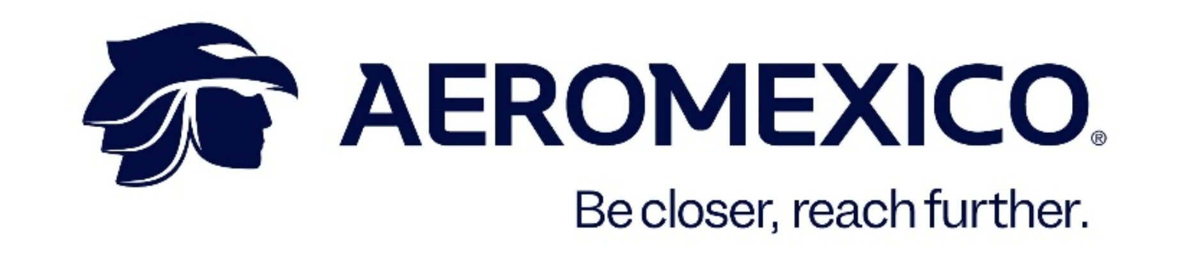

Unusual Movements in the Trading Price of the Shares Representing the Company’s Capital Stock

Mexico City, Mexico, September 18, 2026. In connection with the unusual movements observed on September 18, 2026, in the trading price of the shares representing the capital stock of Grupo Aeroméxico, S.A.B. de C.V. (“Aeroméxico” or the “Company”) (BMV & NYSE: AERO), at the request of the Mexican National Banking and Securities Commission (Comisión Nacional Bancaria y de Valores), pursuant to Article 106 of the Mexican Securities Market Law (Ley del Mercado de Valores) and Article 50, penultimate paragraph, of the General Regulations Applicable to Securities Issuers and Other Securities Market Participants (Disposiciones de carácter general aplicables a las emisoras de valores y a otros participantes del mercado de valores), the Company informs that it is not aware of the causes that may have given rise to such movements, other than those that may be explained by publicly available information, including the publication relating to the holding of a General Shareholders’ Meeting of the Company.

Based on the information available to the issuer as of this date, and after having carried out the procedure to gather information pursuant to Article 53 of the General Regulations Applicable to Securities Issuers and Other Securities Market Participants, the Company informs that it is not aware that members of its Board of Directors or relevant officers participated in such unusual movements. Decisions by third parties regarding the investment in, or sale of, Aeroméxico shares are outside the control of the Company’s management.

Contact:
Investor Relations aminvestorrelations@aeromexico.com
Corporate Communications amcomunicacioncorporativa@aeromexico.com

About Grupo Aeroméxico
Grupo Aeroméxico, S.A.B. de C.V. is a holding company whose subsidiaries are engaged in commercial aviation in Mexico and the promotion of passenger loyalty programs. Aeroméxico, Mexico’s global airline, has its main hub at Terminal 2 of Mexico City International Airport. Its destination network covers Mexico, the United States, Canada, Central America, South America, Asia and Europe. The Group’s current operating fleet includes Boeing 787 and 737 aircraft, as well as Embraer 190 aircraft. Aeroméxico is a founding member of SkyTeam, an alliance that has been operating for more than 25 years and offers connectivity in more than 145 countries through its 18 member airlines.
www.aeromexico.com
www.skyteam.com

Forward-Looking Statements
This press release contains certain forward-looking statements within the meaning of the Private Securities Litigation Reform Act, which reflect the current views and/or expectations of the Company and its management regarding its performance, business and future events. We use words such as “believes,” “anticipates,” “plans,” “expects,” “intends,” “target,” “estimates,” “projects,” “foresees,” “guidance,” “forecast,” “outlook” and other similar expressions to identify such statements. These statements are subject to various risks, uncertainties and assumptions. Several factors could cause actual results to differ materially from the plans, objectives, expectations, estimates and intentions expressed in this press release. Such factors include, among others: external risks, safety and security concerns, health threats, accidents, global instability, security breaches, terrorism and natural disasters; economic and geopolitical conditions in Mexico and internationally, as well as their impact on customer travel behavior and fuel prices; volatility in the fuel market; the Company’s ability to meet its financial obligations, obtain financing and maintain liquidity; its ability to attract and retain key personnel, as well as the Company’s labor relations with its employees; dependence on aircraft manufacturers and other suppliers; aircraft maintenance costs and utilization; changes in airport fees; air traffic congestion; the competitive environment of the aviation industry; dependence on partnerships and alliances, as well as the challenges of entering into new partnerships and alliances; and other factors described in the “Risk Factors” section of the Company’s annual report on Form 20-F filed with the SEC on April 30, 2026, as well as in other documents filed with or furnished to the SEC. Forward-looking statements are based on information available at the time they are made and on management’s good-faith belief regarding future events. The Company undertakes no obligation to update or revise any forward-looking statements, except as required by applicable law. The Company also undertakes no obligation to inform the market, through official announcements, of future purchases of shares by its directors and officers, except as required by applicable law.

